**Assignment No. 01**

**Question:** SDLC Overview - Create a one-page info graphic that outlines the SDLC phases (Requirements, Design, Implementation, Testing, Deployment), highlighting the importance of each phase and how they interconnect.

**Solutions:**

* SDLC or the Software Development Life Cycle is a process that produces software with the highest quality and lowest cost in the shortest time possible. SDLC provides a well-structured flow of phases that help an organization to quickly produce high-quality software which is well-tested and ready for production use.
* Let’s explore the different stages of the Software Development Life Cycle.

**Diagram:** 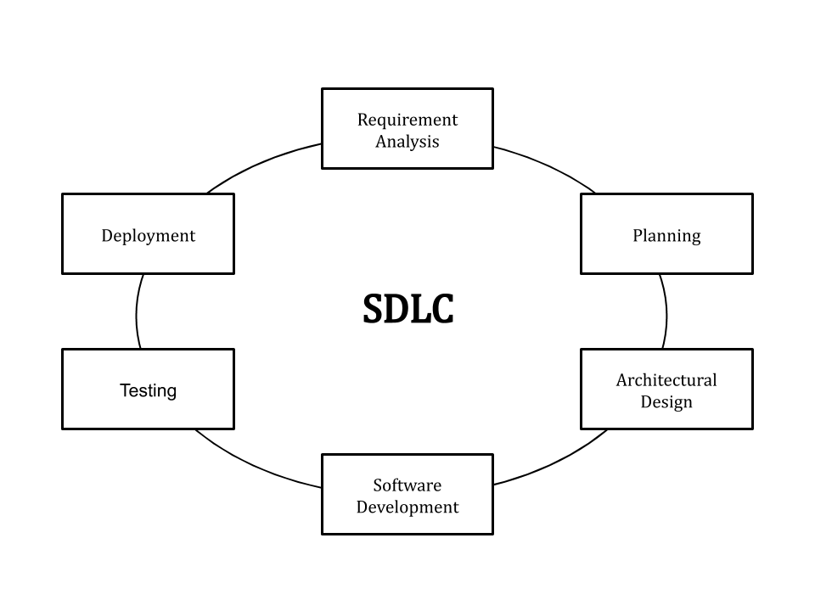

1. **Requirement Analysis**

In this stage, all the requirements for the target software are specified. These requirements get approval from customers, market analysts, and stakeholders.

This is fulfilled by utilizing SRS (Software Requirement Specification). This is a sort of document that specifies all those things that need to be defined and created during the entire project cycle.

1. **Panning**

Planning is a crucial step in everything, just as in software development. In this same stage, requirement analysis is also performed by the developers of the organization. This is attained from customer inputs, and sales department/market surveys.

The information from this analysis forms the building blocks of a basic project. The quality of the project is a result of planning. Thus, in this stage, the basic project is designed with all the available information.

1. **Designing**

SRS is a reference for software designers to come up with the best architecture for the software. Hence, with the requirements defined in SRS, multiple designs for the product architecture are present in the Design Document Specification (DDS).

This DDS is assessed by market analysts and stakeholders. After evaluating all the possible factors, the most practical and logical design is chosen for development.

1. **Development product**

At this stage, the fundamental development of the product starts. For this, developers use a specific programming code as per the design in the DDS. Hence, it is important for the coders to follow the protocols set by the association. Conventional programming tools like compilers, interpreters, debuggers, etc. are also put into use at this stage. Some popular languages like C/C++, Python, Java, etc. are put into use as per the software regulations.

1. **Testing**

After the development of the product, testing of the software is necessary to ensure its smooth execution. Although, minimal testing is conducted at every stage of SDLC. Therefore, at this stage, all the probable flaws are tracked, fixed, and retested. This ensures that the product confronts the quality requirements of SRS.

1. **Deployment and Maintenance product**

After detailed testing, the conclusive product is released in phases as per the organization’s strategy. Then it is tested in a real industrial environment. It is important to ensure its smooth performance. If it performs well, the organization sends out the product as a whole. After retrieving beneficial feedback, the company releases it as it is or with auxiliary improvements to make it further helpful for the customers. However, this alone is not enough. Therefore, along with the deployment, the product’s supervision.